Self Service Checkout Register (CLI)

# Model

# Test Plan

## Scan Item

|  |  |  |  |
| --- | --- | --- | --- |
| Barcode | Expected Output | Actual Output | Comments |
| 001 | ITEM: Garlic Paste | PRICE: $0.43 | SUBTOTAL: $0.43 | ITEM: Garlic Paste | PRICE: $0.43 | SUBTOTAL: $0.43 | Good |
| 002 | ITEM: Rabbit Legs | PRICE: $7.72 | SUBTOTAL: $8.15 | ITEM: Rabbit Legs | PRICE: $7.72 | SUBTOTAL: $8.15 | Good |
| 123 | ERROR!! Scanned barcode is incorrect | ERROR!! Scanned barcode is incorrect | Good |
| - | ERROR!! Scanned barcode is incorrect | ERROR!! Scanned barcode is incorrect | Good |

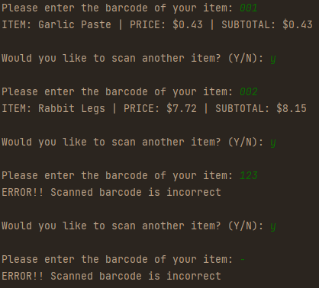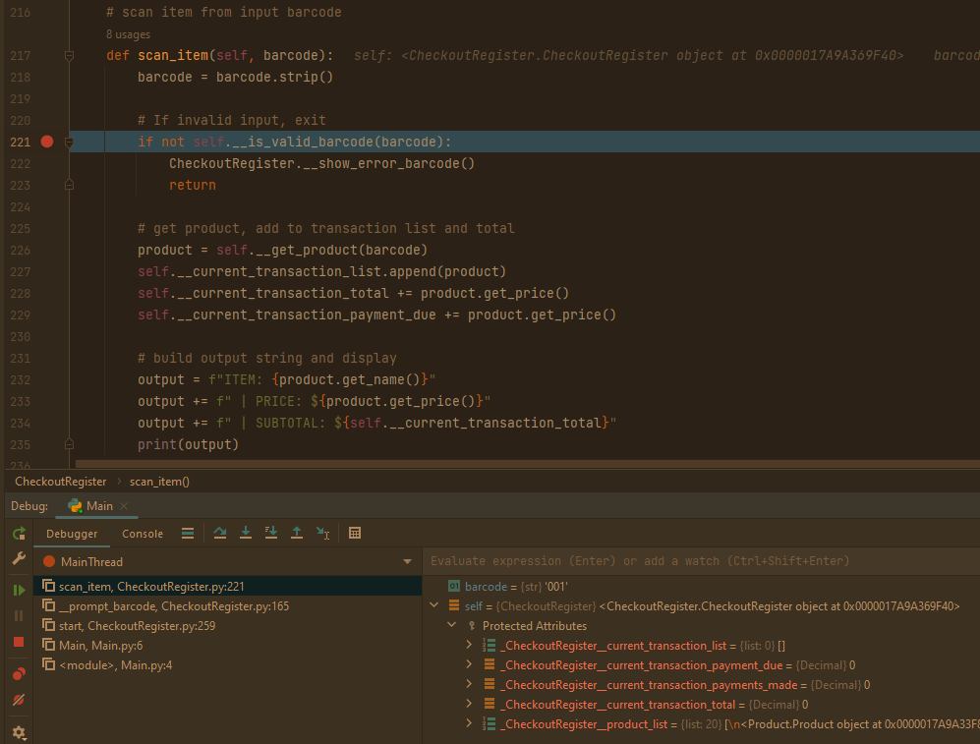

## Accept Payment

|  |  |  |  |
| --- | --- | --- | --- |
| Payment | Expected Output | Actual Output | Comments |
| 3 | Payment due: $5.15 | Payment due: $5.15 | Good |
| 5 | Payment due: $0.15 | Payment due: $0.15 | Good |
| -2 | ERROR!! Invalid amount entered. Please try again. | ERROR!! Invalid amount entered. Please try again. | Good |
|  | ERROR!! Invalid amount entered. Please try again. | ERROR!! Invalid amount entered. Please try again. | Good |

